Botswana

## Freedom House political status

The data set shows the Freedom House political scores and status of the country each year.

## # A tibble: 19 x 5  
## country iso3c date mean status  
## <chr> <chr> <dbl> <dbl> <chr>   
## 1 Botswana BWA 1996 2 Free   
## 2 Botswana BWA 1998 2 Free   
## 3 Botswana BWA 2000 2 Free   
## 4 Botswana BWA 2002 2 Free   
## 5 Botswana BWA 2003 2 Free   
## 6 Botswana BWA 2004 2 Free   
## 7 Botswana BWA 2005 2 Free   
## 8 Botswana BWA 2006 2 Free   
## 9 Botswana BWA 2007 2 Free   
## 10 Botswana BWA 2008 2 Free   
## 11 Botswana BWA 2009 2.5 Free   
## 12 Botswana BWA 2010 2.5 Free   
## 13 Botswana BWA 2011 2.5 Free   
## 14 Botswana BWA 2012 2.5 Free   
## 15 Botswana BWA 2013 2.5 Free   
## 16 Botswana BWA 2014 2.5 Free   
## 17 Botswana BWA 2015 2.5 Free   
## 18 Botswana BWA 2016 2.5 Free   
## 19 Botswana BWA 2017 2.5 Free

## Freedom House classification of political change

The data set shows the GDP growth and the ecomic growth classification of the country each year.

## # A tibble: 19 x 4  
## country iso3c date politicalChangeFH  
## <chr> <chr> <dbl> <chr>   
## 1 Botswana BWA 1996 no change   
## 2 Botswana BWA 1998 no change   
## 3 Botswana BWA 2000 no change   
## 4 Botswana BWA 2002 no change   
## 5 Botswana BWA 2003 no change   
## 6 Botswana BWA 2004 no change   
## 7 Botswana BWA 2005 no change   
## 8 Botswana BWA 2006 no change   
## 9 Botswana BWA 2007 no change   
## 10 Botswana BWA 2008 no change   
## 11 Botswana BWA 2009 autocratization   
## 12 Botswana BWA 2010 no change   
## 13 Botswana BWA 2011 no change   
## 14 Botswana BWA 2012 no change   
## 15 Botswana BWA 2013 no change   
## 16 Botswana BWA 2014 no change   
## 17 Botswana BWA 2015 no change   
## 18 Botswana BWA 2016 no change   
## 19 Botswana BWA 2017 no change

## Freedom House score trend

The plot shows the Freedom House scores trend of the country.

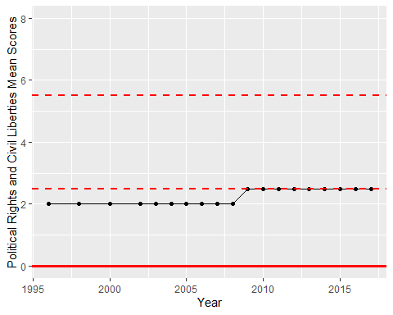

Freedom House Score Trend